CHAITANYA BHARATHI INSTITUTE OF TECHNOLOGY



**BUS TICKETS**

**BOOKING**

**------------------------------**

**PROJECT WORK**

**DONE BY:**

**LANKA SRAVAN SAI**

**160119737113**

**IT-2**

**MOBLIE: 9390229549**

**CONSTRAINTS :**

1.This program is written in C-language.

2.Three buses of fixed routes and each bus has 40 seats.

3.Maximum six tickets can be booked per booking.

4. “ * ”- selected seats and “ @ ”-Occupied.

5.Contact number should be 10-digited number.

6.Bill is printed on the console immediately after booking.

7.Four options are given after every booking.

a) Display bus details.

b) Check seat availability.

c) Book again.

d) Display previous bookings.

8.’Display of previous bookings’ option shows all bookings of respective run time. When program terminates all the details are transferred into another file.

9.The program is illustrated with console outputs at

respective places.

**PROGRAM STARTS HERE :**

#include<stdio.h>

#include<stdlib.h>

#include<string.h>

struct bus_details

{

char* from_to;

int bus_no,fare;

}b[3];

struct passengers_details

{

int age;

char name[20];

}pass[6];

struct previous_booking

{

int bus_num;

char from_to[8];

int tickets,amount;

char contact_num[20];

}f;

void display_bus_details()

{

int i;

b[0].from_to="HYD-VIJ";

b[1].from_to="HYD-VIZ";

b[2].from_to="HYD-RJM";

b[0].bus_no=1432;

b[1].bus_no=2341;

b[2].bus_no=8854;

b[0].fare=450;

b[1].fare=1000;

b[2].fare=750;

printf("\nBUS DETAILS :\n");

printf("\t\tFrom-to\t\tBus no\t\tFare(per ticket)\n\n");

for(i=0;i<3;i++)

{

printf("\t\t%s\t\t%d\t\t%d\n",b[i].from_to,b[i].bus_no,b[i].fare);

}

printf("\t\tHYD-Hyderabad\nVIJ-Vijayawada\nVIZ-Vizag\nRJM-Rajamundry\n");

}

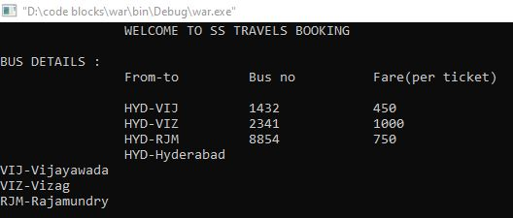

void scan_tickets(int s[],int seat_no[],int *p)

{

int i,j,count;

printf("enter no of tickets:");

scanf("%d",p);

while(*p>6 ||*p<=0 )

{

while(*p<=0)

{

printf("No of tickets at least should be %d\nenter number of tickets:",1);

scanf("%d",p);

}

printf("max tickets can be booked at a time are %d\nenter number of tickets:",6);

scanf("%d",p);

}

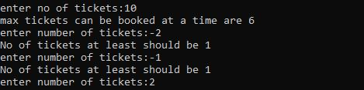

printf("enter seat numbers\n");

i=0;

while(i<(*p))

{

scanf("%d",&seat_no[i]);

if(seat_no[i]>40 || seat_no[i]<1)

{

printf("OOPS..! You have entered a wrong seat number\n");

printf("Re-enter the seat number:");

continue;

}

if(s[seat_no[i]-1]==64)

{

printf("seat is occupied");

printf("\nEnter another seat:" );

continue;

}

count=0;

for(j=0;j<i;j++)

if(seat_no[i]==seat_no[j])

count++;

if(count==0)

{

i++;

}

else

{

printf("%d seat number is selected\n",seat_no[i]);

printf("re enter the seat number:");

}

}

}

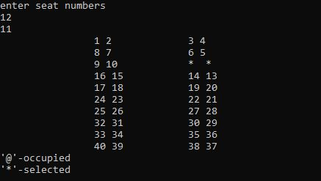

void Bus(int s[],int seat_no[],int *p)

{

int i;

scan_tickets(s,seat_no,p);

for(i=0;i<(*p);i++)

s[seat_no[i]-1]=42;

current_seats(s);

for(i=0;i<(*p);i++)

s[seat_no[i]-1]=64;

}

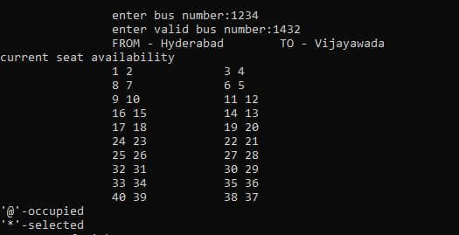

void current_seats(int s[])

{

int i;

printf("\t\t");

for(i=0;i<40;i++)

{

if(i%8==0 || i%8==1 || i%8==2 || i%8==3)

{

if(s[i]==42 || s[i]==64)

printf("%c ",s[i]);

else

printf("%d ",s[i]);

}

else

{

if(i%8==4)

{

if(s[i+3]==42 || s[i+3]==64)

printf("%c ",s[i+3]);

else

printf("%d ",s[i+3]);

}

else if(i%8==5)

{

if(s[i+1]==42 || s[i+1]==64)

printf("%c ",s[i+1]);

else

printf("%d ",s[i+1]);

}

else if(i%8==6)

{

if(s[i-1]==42 || s[i-1]==64)

printf("%c ",s[i-1]);

else

printf("%d ",s[i-1]);

}

else

{

if(s[i-3]==42 || s[i-3]==64)

printf("%c ",s[i-3]);

else

printf("%d ",s[i-3]);

}

}

if((i+1)%2==0)

printf("\t\t");

if((i+1)%4==0)

printf("\n\t\t");

}

printf("\b\b\b\b\b\b\b\b\b\b\b\b\b\b\b\b'@'-occupied\n'*'-selected \n");

}

void pass_details(struct passengers_details pa[],int *p)

{

int i;

printf("\n\tPassengers details");

for(i=1;i<=(*p);i++)

{

printf("\npassenger %d:",i);

printf("\n\tname:");

fflush(stdin);

gets(pa[i-1].name);

printf("\tage :");

fflush(stdin);

scanf("%d",&pa[i-1].age);

printf("\n");

}

}

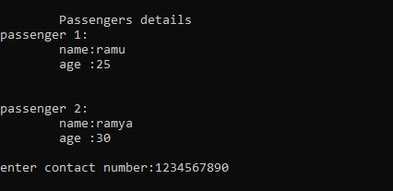

void bill(struct previous_booking m,struct bus_details s[],struct passengers_details p[],int seat_no[],char num[],int seats,int busno)

{

FILE *fp;

int i,x;

printf("\n\n******************BILL*****************\n");

printf("BUS NO:%d\n",busno);

printf("FROM - Hyderabad\t");

if(busno==s[0].bus_no)

{

printf("TO - Vijayawada\n");

x=0;

}

else if(busno==s[1].bus_no)

{

printf("TO - Vizag\n");

x=1;

}

else

{

printf("TO - Rajamundry\n");

x=2;

}

f.bus_num=busno;

strcpy(f.from_to,b[x].from_to);

f.tickets=seats;

f.amount=seats*(s[x].fare);

strcpy(f.contact_num,num);

fp=fopen("previous_booking.dat","a");

fwrite(&f,sizeof(f),1,fp);

fclose(fp);

printf("PASSENGERS DETAILS\n");

printf("name(age) - seat number\n");

for(i=0;i<seats;i++)

printf("%s(%d) - %d\n",p[i].name,p[i].age,seat_no[i]);

printf("CONTACT NUMBER - ");

printf("%s\n",num);

printf("NUMBERS OF SEATS - %d\n",seats);

printf("TOTAL AMOUNT - %d\n",seats*(s[x].fare));

printf("****************************************\n\n");

}

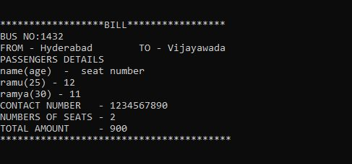

void display_previous_booking(struct previous_booking f,int no_of_bookings)

{

FILE *fp;

int i;

fp=fopen("previous_booking.dat","a+");

printf("BUS_NO\t\tFROM_TO\t\tNO_OF_TICKETS\t\tTOTAL_AMOUNT\t\tCONTACT_NUM\n");

for(i=0;i<no_of_bookings;i++)

{

fread(&f,sizeof(f),1,fp);

printf("%d \t\t%s\t\t%d\t\t\t%d\t\t\t %s \n",f.bus_num,f.from_to,f.tickets,f.amount,f.contact_num);

}

fclose(fp);

}

int main()

{

int A[40],B[40],C[40],bus_number,count=0,choice;

char contactnum[20];

int seat_no[6],no_of_tickets,i,no_of_bookings=1;

FILE *fp,*fp1;

printf(" WELCOME TO SS TRAVELS BOOKING\n");

display_bus_details();

printf("\n\t\tenter bus number:");

while(1)

{

scanf("%d",&bus_number);

for(i=0;i<3;i++)

if(bus_number==b[i].bus_no)

count++;

if(count==1)

break;

else

printf("\t\tenter valid bus number:");

}

for(i=0;i<40;i++)

{

A[i]=i+1;

B[i]=i+1;

C[i]=i+1;

}

while(1)

{

printf("\t\tFROM - Hyderabad\t");

if(bus_number==b[0].bus_no)

{

printf("TO - Vijayawada\n");

printf("current seat availability\n");

current_seats(A);

Bus(A,seat_no,&no_of_tickets);

}

else if(bus_number==b[1].bus_no)

{

printf("TO - Vizag\n");

printf("current seat availability\n");

current_seats(B);

Bus(B,seat_no,&no_of_tickets);

}

else

{

printf("TO - Rajamundry\n");

printf("current seat availability\n");

current_seats(C);

Bus(C,seat_no,&no_of_tickets);

}

pass_details(pass,&no_of_tickets);

while(1)

{

printf("enter contact number:");

scanf("%s",contactnum);

if(strlen(contactnum)==10)

break;

else

printf("enter a 10-Digit contact number\n");

}

bill(f,b,pass,seat_no,contactnum,no_of_tickets,bus_number);

while(1)

{

printf("\n\n1.Dispaly bus details\n");

printf("2.Check seat availability\n");

printf("3.Book again\n");

printf("4.Display previous booking\n");

printf("enter any character to exit booking\n");

printf("Enter any option number:");

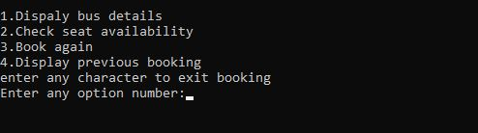

scanf("%d",&choice);

if(choice==1)

{

display_bus_details();

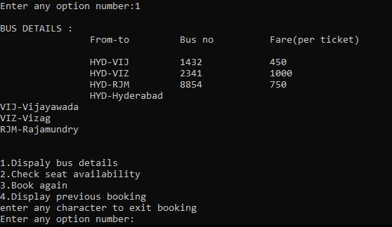

}

else if(choice==2)

{

printf("enter bus number:");

while(1)

{

count=0;

scanf("%d",&bus_number);

for(i=0;i<3;i++)

if(bus_number==b[i].bus_no)

count++;

if(count==1)

break;

else

printf("enter valid bus number:");

}

if(bus_number==b[0].bus_no)

current_seats(A);

else if(bus_number==b[1].bus_no)

current_seats(B);

else

current_seats(C);

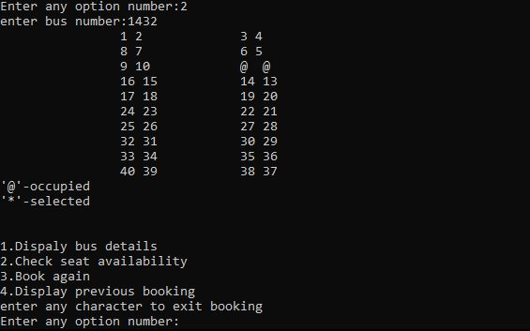

}

else if(choice==3)

{

count=0;

printf("enter bus number:");

while(1)

{

scanf("%d",&bus_number);

for(i=0;i<3;i++)

if(bus_number==b[i].bus_no)

count++;

if(count==1)

break;

else

printf("enter valid bus number:");

}

no_of_bookings++;

break;

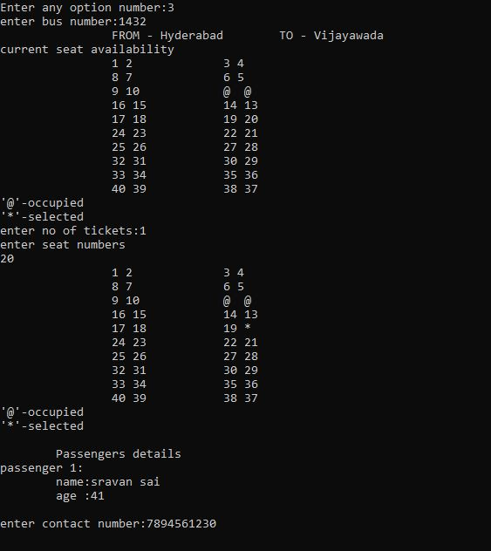

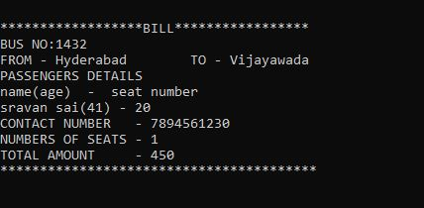

}

else if(choice==4)

{

display_previous_booking(f,no_of_bookings);

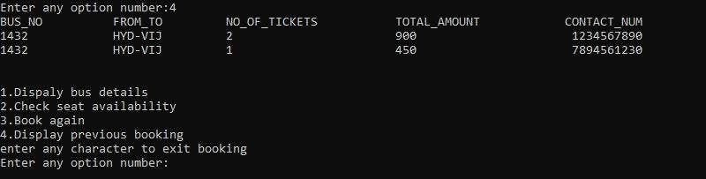

}

else

{

char ch;

fp=fopen("previous_booking.dat","r");

fp1=fopen("previous_records.dat","a");

while((ch=fgetc(fp))!=EOF)

{

fputc(ch,fp1);

}

fclose(fp);

fp=fopen("previous_booking.dat","w");

fclose(fp);

fclose(fp1);

printf("\n\n<<<<<<<<<<<<<THANK YOU FOR BOOOKING>>>>>>>>>>>>>>>>\n\n");

return 0;

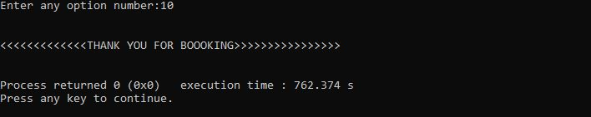

}

}

}

}

**OUTPUT :**

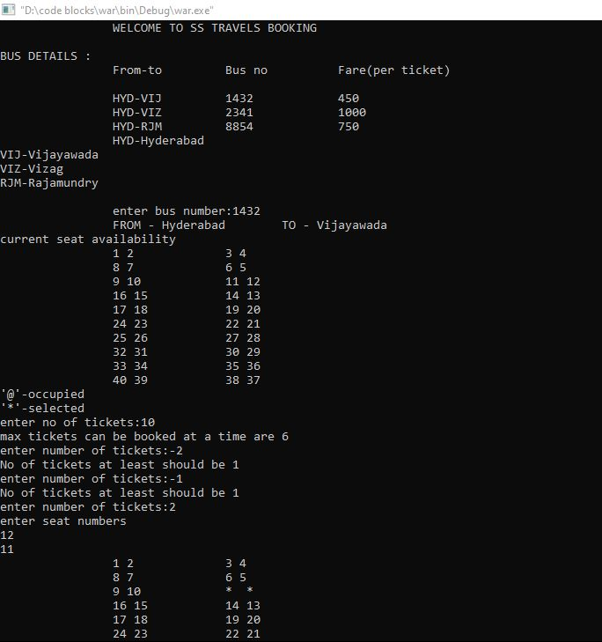

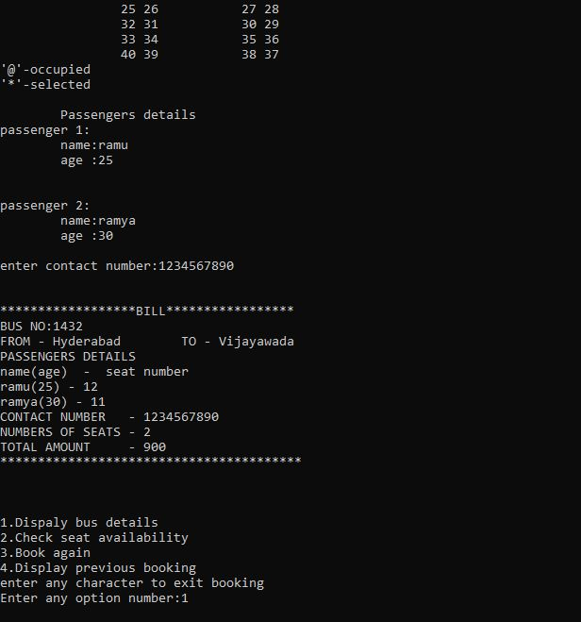

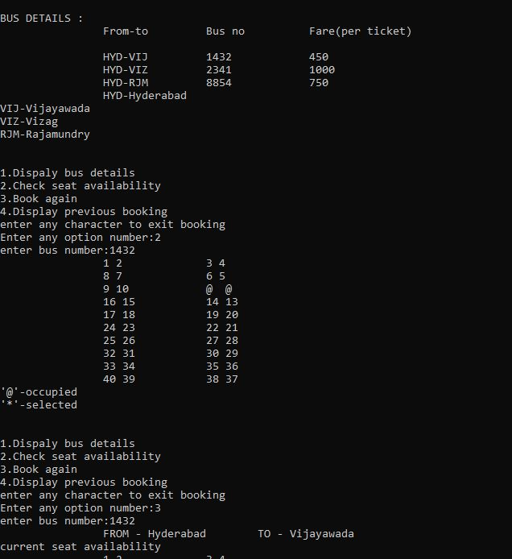

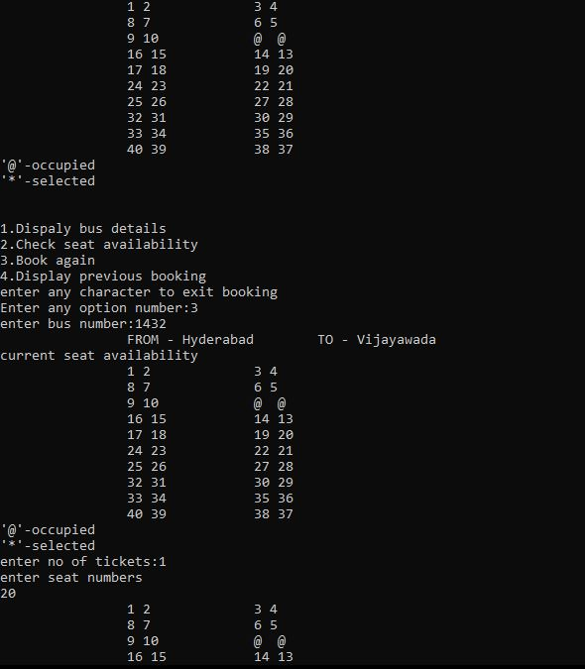

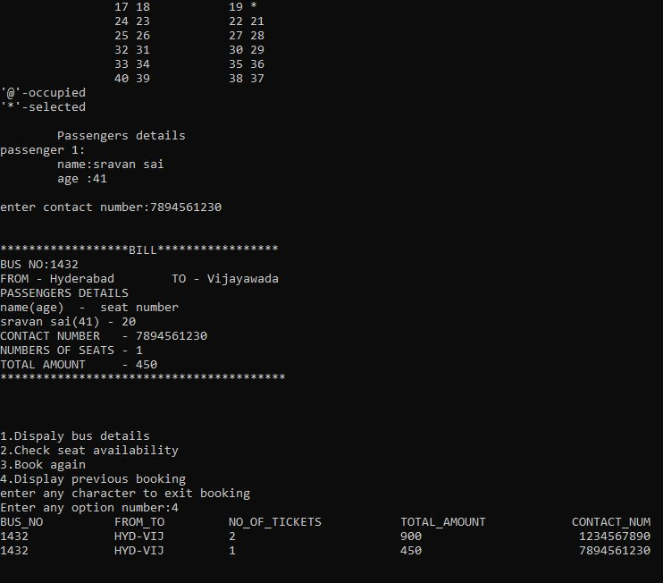

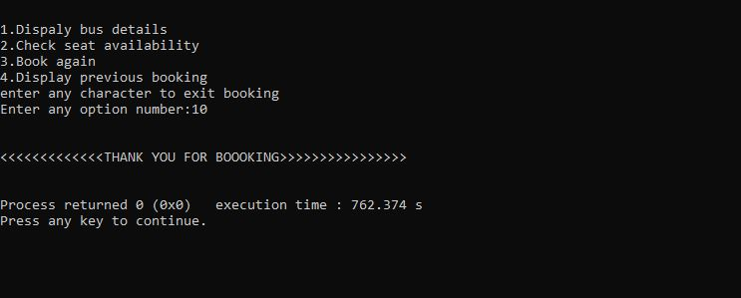

**---------------------------THE END----------------------------**